# Apply filters to SQL queries

## Project description

[Describe what you accomplish through SQL.]

## Retrieve after hours failed login attempts

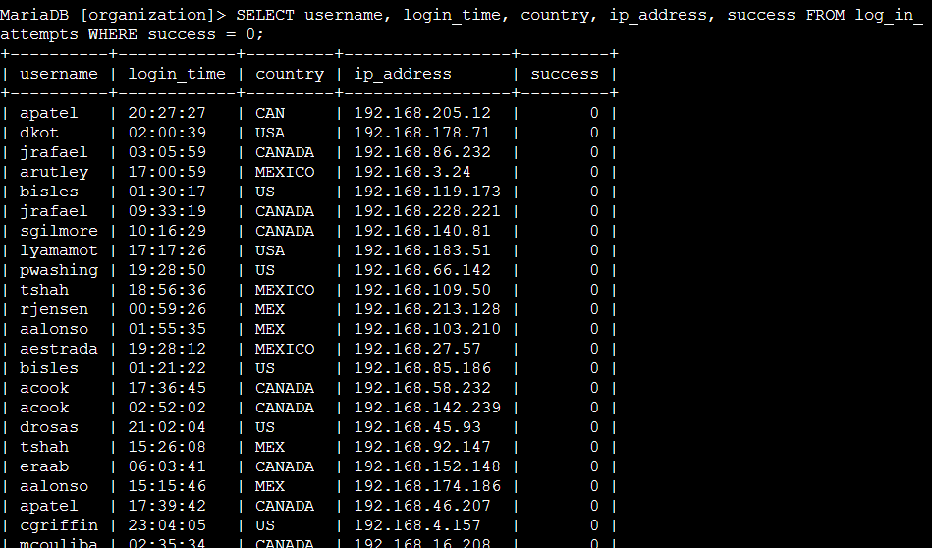

This command shows all of the attempts that are failed by analyzing the success column and checking if it’s 0 (failed). Then it shows the username, the time of the attempts, more information pertaining to the user that did the attempt and just to be sure that the attempts are negative, the 0 or 1.

## Retrieve login attempts on specific dates

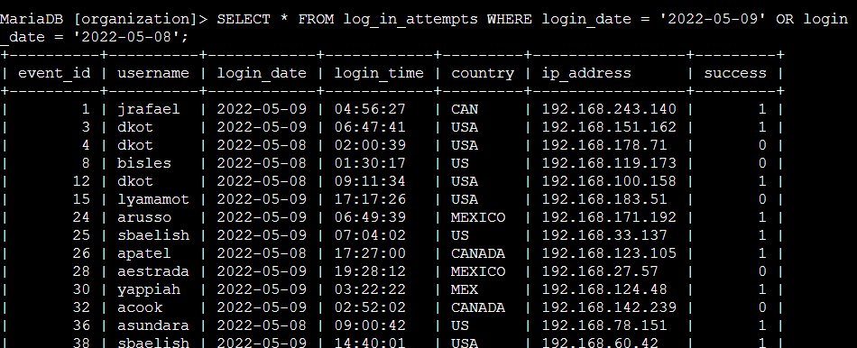

This command checks the 2022-05-08 and 2022-05-09 dates

## Retrieve login attempts outside of Mexico

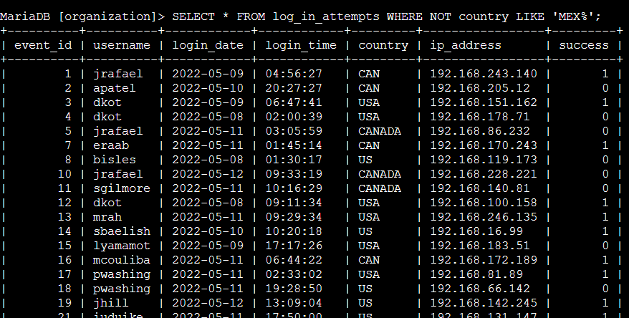

It retrieves all the countries except for mexico.

## Retrieve employees in Marketing

## Retrieve employees in Finance or Sales

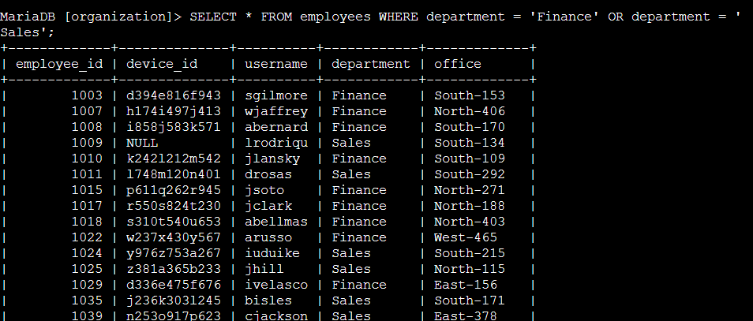

## Retrieve all employees not in IT



## Summary

[Add content here.]